Practical no. 18
Name :- Danish Altaf Solkar Enrolment no. :-24111590805
Class :- CO3K – B Subject :- DMS
Aim:- Implement PL/SQL program using Conditional Statements

Program :-
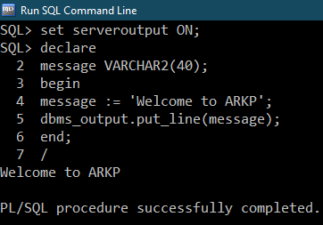

Program :-
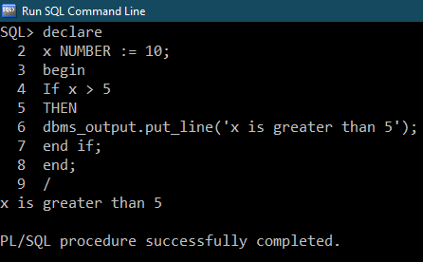
Program :-
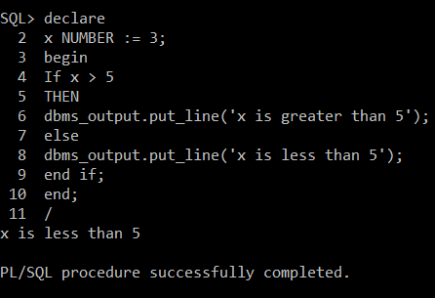
Program :-
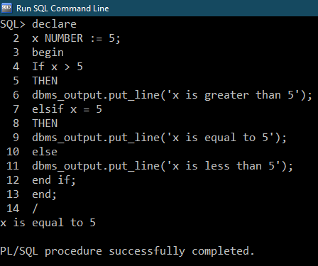

Program :-
